Utility or Collection Framework 3
Why Collection Framework 3
What is Collection Framework? 3
Class Hierarchy of Collection Framework 3
Collection Interface 4
Enumeration Interface 4
Iterator Interface 4
ListIterator Interface 5
How to use Iterator 5
Group Operations 5
Set Interface 5
HashSet, TreeSet, LinkedHashSet 6
List Interface 6
Vector, ArrayList, LinkedList Classes 7
Map Interface 8
Map.Entry Interface 8
HashMap, TreeMap Classes 8
Performance comparison of different ways to iterate over HashMap 8
WeakHashMap Class 9
ConcurrentHashMap Class 9
Comparable Interface 9
Comparator Interface 10
Read only Collections 10
Thread-Safe Collections 10
Hashtable, Properties Classes 11
Stack, Queue, Priority Queue 11
Object Cloning 11
What is Cloning 11
Why Cloning Required 12
Shallow Cloning 12
Deep Cloning 12
Cloning with serialization 13
Prototype & Singleton design pattern 13
Java Concurrency / Multithreading 14
What do mean by Multithreading? 14
Multiprocessing and Multitasking 14
What is a Thread? 14
Life cycle of Thread 14
Different ways to create a Thread 15
Working with a Thread 15
Locks / Thread synchronization 16
Volatile variables 18
Wait – Notify - NotifyAll 19
Inter – Thread Communication 19
Executors, Schedule Executor & Thread Pool 19
Futures and Callables 20
Nonblocking algorithms 20
ReentrantLock 20
Lock vs synchronized 20
Java 5 features 20
For each loop 20
Var-args 21
AutoBoxing 21
Generics 21
Enum 22
Covariant Return 22
Annotation 23
Static Import 25
JDBC Connectivity 26
Types of Driver 26
Install & Configure Database 27
Steps to Create a Database Connection 30
Create few table using SQL Scrapbook 31
Database URL’s 31
Read data from Database using Statement 31
Read data from Database using PreparedStatement 31
Read data from Database using DataSource 32
ResultSet Type 32
ResultSet Concurrency 33
ResultSet Holdability 33
Insert data into Database 33
Update data into Database 33
Delete data from Database 33
Batch Updates 33
Rowset 35
CallableStatement 36
Connection Pooling using JNDI Services 37
Inside Tomcat using Servlet.xml 37
Connection Pooling using Context.xml 39
Java 6 features 40
WebService 40
Rhino 40
Derby DB 41
Deque 41
JavaTM API for XML Processing (JAXP) 41
JDBC 4.0 Enhancements 41
Java 7 features 43
Strings in switch 43
Binary Literals with prefix "0b" 43
Catching Multiple Exception Types 43
The try-with-resources Statement 43
Type Inference for Generic Instance Creation 43
Rethrowing Exceptions with Improved Type Checking 43
JUNIT & TDD 44
Unit tests and unit testing 44
The JUnit framework 44
JUnit naming conventions 44
JUnit test suites 44
TDD Aproach 44
Run your test from the command line 45
Available JUnit annotations 46
Assert statements 47

Utility or Collection Framework
Why Collection Framework
Collections are nothing but group of objects stored in well defined manner. Earlier, Arrays are used to represent these groups of objects. But, arrays are not re-sizable. Size of the arrays is fixed. Size of the arrays can not be changed once they are defined. This causes lots of problem while handling group of objects. To overcome this drawback of arrays, Collection framework or simply collections are introduced in java from JDK 1.2.

Although, there were classes like Dictionary, Vector, Stack and Properties which handle group of objects better than the arrays. But, each of them handles the objects differently. The way you use Dictionary class is totally different from the way you use Stack class and the way you use Vector class is different from the way you use Properties class. Hence, there needed a central and unifying theme to handle the group of objects. That’s why we need collection framework.

What is Collection Framework?
Collection Framework in java is a centralized and unified theme to store and manipulate the group of objects. Java Collection Framework provides some pre-defined classes and interfaces to handle the group of objects. Using collection framework, you can store the objects as a list or as a set or as a queue or as a map and perform operations like adding an object or removing an object or sorting the objects without much hard work.
Class Hierarchy of Collection Framework
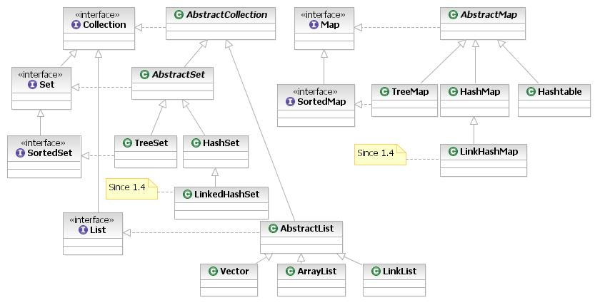
Interface | Implementation |  |  |  | Historical
Set | HashSet |  | TreeSet | LinkedHashSet |  | It handles list of objects which must contain unique element.
List |  | ArrayList |  | LinkedList | Vector  Stack | It handles sequential list of objects.
Map | HashMap |  | TreeMap |  | Hashtable  Properties | This is the one interface in Collection Framework which is not inherited from Collection interface. It handles group of objects as Key/Value pairs
Queue |  | PriorityQueue |  | LinkedList |  | It handles special list of objects in which elements are removed only from the head.
The entire collection framework is divided into four interfaces.
Collection: A collection is an object that represents a group of objects (such as Vector, ArrayList, etc). The primary advantages of a collections framework are that it:
i) Reduces programming effort by providing useful data structures and algorithms so you don't have to
write them yourself.
ii) Increases performance by providing high-performance implementations of useful data structures and
algorithms. Because the various implementations of each interface are interchangeable, programs can be
easily tuned by switching implementations.
iii) Reduces the effort required to learn APIs
iv) Reduces the effort required to design and implement APIs

Collection Interface
There are fourteen collection interfaces. The most basic interface is Collection. These interfaces extend Collection: Set, List, SortedSet, NavigableSet, Queue, Deque, BlockingQueue and BlockingDeque. The other collection interfaces, Map, SortedMap, NavigableMap, ConcurrentMap and ConcurrentNavigableMap do not extend Collection, as they represent mappings rather than true collections. However, these interfaces contain collection-view operations, which allow them to be manipulated as collections.

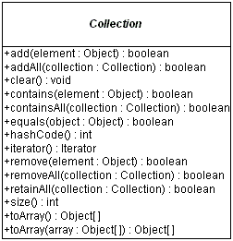
Enumeration Interface
A class that implements Enumeration interface provides access to series of elements one at a time. You need to call nextElement method to get next element in the series. Also hasMoreElements () method gives you status about the availability of next element in the series.
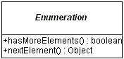
Example - com.src.java.collection – MyEnumeration.java

Question: Why Java1.5 onwards Java has retricted to store Homogenous type of Objects inside any Collection using Generics? OR Why java has introduced Generic Java1.5 onwards?

Iterator Interface
All of the collection classes provides iterator () method to iterate through the collection. The iterator () method returns the Iterator object through which you can access the collection elements in an order. Enumeration also does the same purpose. The difference between Iterator and Enumerations is: Iterators allow the caller to remove elements from the underlying collection during the iteration with well-defined semantics.
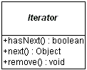
Example - com.src.java.collection – MyCollectionIterator.java, MyItrRemoveElement.java

Question: Difference between Enumeration & Iterator?
Only major difference between Enumeration and iterator is Iterator has a remove () method while Enumeration doesn't. Enumeration acts as Read-only interface, because it has the methods only to traverse and fetch the objects, where as by using Iterator we can manipulate the objects like adding and removing the objects from collection e.g. Arraylist.
Also Iterator is more secure and safe as compared to Enumeration because it does not allow other thread to modify the collection object while some thread is iterating over it and throws ConcurrentModificationException.

Question: When & why we get ConcurrentModificationException?
ListIterator Interface
The ListIterator interface extends the Iterator interface to support bi-directional access, as well as adding or changing elements in the underlying collection. Using ListIterator, we can iterate all elements of a list in either direction. You can access next element by calling next () method, and also you can access previous element by calling previous () method on the list.
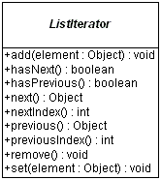

Example - com.src.java.collection – MyListIterator.java

Question: Difference between Iterator & ListIterartor?
Iterator | ListIterator
Iterator () method is available for all collections. That is, Iterator can be used for all collection classes. | ListIterator () method is available for those collections that implement List interface. That is, descendents of List interface only can use ListIterator.
Can do remove operation only on elements | Can remove, add and replace elements

Question: Which one we should use For loop OR iterator in multithreading environment to work on a collection? Why?

How to use Iterator
There are two kinds of Iterator in Java, fail-safe (ConcurrentHashMap) and fail-fast (ArrayList, HashMap, HashSet, etc). Fail-safe Iterator doesn't throw ConcurrentModificationException during iteration while fail-fast does, if, Iterator realizes any structural change in Collection once Iteration begins.
Example - com.src.java.collection – IteratorHowToUse.java

Group Operations
Other operations the Collection interface supports are tasks done on groups of elements or the entire collection at once:
- boolean containsAll(Collection collection)
- boolean addAll(Collection collection)
- void clear()
- void removeAll(Collection collection)
- void retainAll(Collection collection)
The containsAll() method allows you to discover if the current collection contains all the elements of another collection, a subset. The remaining methods are optional, in that a specific collection might not support the altering of the collection. The addAll() method ensures all elements from another collection are added to the current collection, usually a union. The clear() method removes all elements from the current collection. The removeAll() method is like clear() but only removes a subset of elements. The retainAll() method is similar to the removeAll() method, but does what might be perceived as the opposite. It removes from the current collection those elements not in the other collection, an intersection.

Set Interface
The Set interface extends the Collection interface and, by definition, forbids duplicates within the collection. All the original methods are present and no new methods are introduced. The concrete Set implementation classes rely on the equals() method of the object added to check for equality.
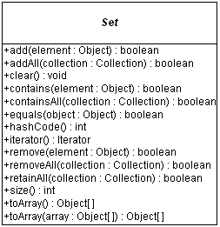

HashSet, TreeSet, LinkedHashSet
HastSet
This class implements the Set interface, backed by a hash table (actually a HashMap instance). It makes no guarantees as to the iteration order of the set; in particular, it does not guarantee that the order will remain constant over time. This class permits the null element.
If we are trying to insert duplicate objects we won't get compile time error and runtime error add() method simply returns false.
Note that this implementation is not synchronized. If multiple threads access a hash set concurrently, and at least one of the threads modifies the set, it must be synchronized externally.
Set s = Collections.synchronizedSet(new HashSet(...));
The iterators returned by this class's iterator method are fail-fast: if the set is modified at any time after the iterator is created, in any way except through the iterator's own removemethod, the Iterator throws a ConcurrentModificationException.

Example - com.src.java.collection – SpellChecker.java
TreeSet
It stores its elements in a red-black tree, orders its elements based on their values; it is substantially slower than HashSet.
The TreeSet implementation is useful when you need to extract elements from a collection in a sorted manner. In order to work property, elements added to a TreeSet must be sortable. The Collections Framework adds support for Comparable elements. It is generally faster to add elements to a HashSet, and then convert the collection to a TreeSet for sorted traversal.
To optimize HashSet space usage, you can tune the initial capacity and load factor. The TreeSet has no tuning options.
Example - com.src.java.collection – TreeSetNaturalOrder.java

LinkedHashSet
It is implemented as a hash table with a linked list running through it, orders its elements based on the order in which they were inserted into the set (insertion-order).

Example - com.src.java.collection – SetComparision.java

Question: Difference among HashSet, TreeSet & LinkedHashSet?
HashSet is fastest, LinkedHashSet is second on performance or almost similar to HashSet but TreeSet is bit slower because of sorting operation it needs to perform on each insertion.
HashSet is backed by a HashMap instance, LinkedHashSet is implemented using HashSet and LinkedList while TreeSet is backed up by NavigableMap in Java and by default it uses TreeMap.
HashSet and LinkedHashSet allow null but TreeSet doesn't allow null but TreeSet doesn't allow null and throw java.lang.NullPointerException when you will insert null into TreeSet. Since TreeSet uses compareTo () method of respective elements to compare them which throws NullPointerException while comparing with null.

List Interface
The List interface extends the Collection interface to define an ordered collection, permitting duplicates.

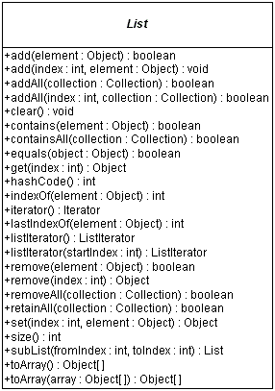

Vector, ArrayList, LinkedList Classes
Vector
Vectors (the java.util.Vector class) are commonly used instead of arrays, because they expand automatically when new data is added to them. The Java 2 Collections API introduced the similar ArrayList data structure. ArrayLists are unsynchronized and therefore faster than Vectors, but less secure in a multithreaded environment. The Vector class was changed in Java 2 to add the additional methods supported by ArrayList.
Example - com.src.java.collection – VectorExample.java

ArrayList
It is resizable-array implementation of the List interface. Implements all optional list operations, and permits all elements, including null. This class is roughly equivalent to Vector, except that it is unsynchronized.
If you need to support random access, without inserting or removing elements from any place other than the end, than ArrayList offers the optimal collection.
Note that this implementation is not synchronized. If multiple threads access an ArrayList instance concurrently, and at least one of the threads modifies the list structurally, it must be synchronized externally.
List list = Collections.synchronizedList(new ArrayList(...));
The iterators returned by this class's iterator and listIterator methods are fail-fast: if the list is structurally modified at any time after the iterator is created, in any way except through the iterator's own remove or add methods, the iterator will throw a ConcurrentModificationException.
Example - com.src.java.collection – SwapArrayList.java

LinkedList
If, however, you need to frequently add and remove elements from the middle of the list and only access the list elements sequentially then LinkedList offers the better implementation. Both ArrayList and LinkedList implement the Cloneable interface. In addition, LinkedList adds several methods for working with the elements at the ends of the list
Example – Mail Box Application always prefer to use LinkList
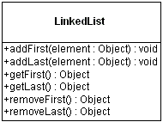
Example - com.src.java.collection – Node.java, SinglyLinkedListImpl.java, SingleLinkedListClient.java
Question- What is difference between Collection & Collections?
Question- How to sort List of Employees based on salary?
Example - com.src.java.collection – Employee.java, SortEmployees.java
Assignment: How we can sort set of Employees?
Question- What is difference between Array, Vector & ArrayList?
Array is fixed size length data structure whereas Vector & ArrayList are auto expandable. ArrayList is not synchronised which will give better performance whereas Vector preferable to used in Multithreaded environment since it is synchronized.
Question- What is difference between ArrayList & LinkedList?
ArrayList is used for fast searching based on Index whereas LinkedList we can use where lots of insertion & deletion operations are required. ArrayList is slower for insertion & deletion since array element shift their position upto last element which takes more time in comparison to LinkedList.

Map Interface
The Map interface is not an extension of the Collection interface. Instead, the interface starts off its own interface hierarchy, for maintaining key-value associations. The interface describes a mapping from keys to values, without duplicate keys, by definition.
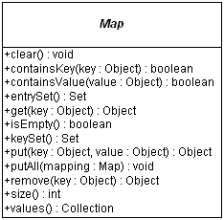

Map.Entry Interface
A map entry (key-value pair). The Map.entrySet method returns a collection-view of the map, whose elements are of this class. The only way to obtain a reference to a map entry is from the iterator of this collection-view. These Map.Entry objects are valid only for the duration of the iteration; more formally, the behavior of a map entry is undefined if the backing map has been modified after the entry was returned by the iterator, except through the setValue operation on the map entry.
The entrySet () method of Map returns a collection of objects that implement Map.Entry interface. Each object in the collection is a specific key-value pair in the underlying Map.
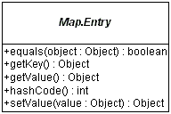

HashMap, TreeMap Classes
For inserting, deleting, and locating elements in a Map, the HashMap offers the best alternative. If, however, you need to traverse the keys in a sorted order, then TreeMap is your better alternative. Depending upon the size of your collection, it may be faster to add elements to a HashMap, and then convert the map to a TreeMap for sorted key traversal. Using a HashMap requires that the class of key added have a well-defined hashCode () implementation. With the TreeMap implementation, elements added to the map must be sortable.
To optimize HashMap space usage, you can tune the initial capacity and load factor. The TreeMap has no tuning options, as the tree is always balanced.

The Hashtable and Properties classes are historical implementations of the Map interface.

HashMap
Example - com.src.java.collection – HashMapDemo.java, Account.java, TestMutableKey.java

Question- How to sort a Map either based on key / value?
Example - com.src.java.collection – SortMapByKeyAndValue.java

Performance comparison of different ways to iterate over HashMap
To compare traversal in hash map in java. HashMap is very frequently used class and most of the times we just fetch the value using get(Object key) method provided by class. But at times it is required to iterate over whole Map and fetch all key-value pairs stored in it. For example, analyzing all request parameters sent from client. If you are using this for every client you will be iterating whole map at least once in your code.
If you are using this type of iteration many places in code and there are large number of requests then you surely would like to optimize your iteration code to make best use of it.

Now let’s compare their performances for a common data set stored in map. I am storing 10 lacs key value pairs in map and will iterate over map in all four ways. I will also fetch key and value from map for all 10 lacs entries in best suitable way. Then i will capture the time taken by each way.

Observations- 10 lacs is very big number of most the application requirements. Even though the difference is not very substantial in milliseconds, as compare to it was very big in case of for loops. I believe most of us can live with such a minor difference.
But if you want to be very specifically make the conclusion, using entry set is more powerful and yields better performance as comparing to using key set for iteration. Result varies from 20% -- 50% when above program is executed multiple times.

Example - com.src.java.collection – DifferentWaysToIterateOverHashMap.java

TreeMap
Example - com.src.java.collection – MyTreeMapComparator.java, SortMapByKeyAndValue.java

Assignment: Create a complete Dictionary feature implementation using Collection.

WeakHashMap Class
A hashtable-based Map implementation with weak keys. An entry in a WeakHashMap will automatically be removed when its key is no longer in ordinary use. More precisely, the presence of a mapping for a given key will not prevent the key from being discarded by the garbage collector, which is, made finalizable, finalized, and then reclaimed. When a key has been discarded its entry is effectively removed from the map, so this class behaves somewhat differently than other Map implementations. Both null values and the null key are supported.
Like most collection classes, this class is not synchronized. A synchronized WeakHashMap may be constructed using the Collections.synchronizedMap method.
Example - com.src.java.collection – WeakHashMapExample.java
Question- Where can we use WeakHashMap?
WeakHashMap to avoid memory leaks. WeakHashMap can also be used fairly straightforwardly as a cache that can be cleared automatically when JVM memory is low.

ConcurrentHashMap Class
The ConcurrentHashMap is very similar to the java.util.HashTable class, except that ConcurrentHashMap offers better concurrency than HashTable does. ConcurrentHashMap does not lock the Map while you are reading from it. Additionally, ConcurrentHashMap does not lock the entire Map when writing to it. It only locks the part of theMap that is being written to, internally.
Another difference is that ConcurrentHashMap does not throw ConcurrentModificationException if theConcurrentHashMap is changed while being iterated. The Iterator is not designed to be used by more than one thread though.
Example - com.src.java.collection – ConcurrentHashMapExample.java
Question- What is difference between Hashtable & ConcurrentHashMap?

Comparable Interface
This interface imposes a total ordering on the objects of each class that implements it. This ordering is referred to as the class's natural ordering, and the class's compareTo method is referred to as its natural comparison method.
Lists (and arrays) of objects that implement this interface can be sorted automatically by Collections.sort (and Arrays.sort). Objects that implement this interface can be used as keys in a sorted map or elements in a sorted set, without the need to specify a comparator.
The natural ordering for a class C is said to be consistent with equals if and only if (e1.compareTo((Object)e2) == 0) has the same boolean value as e1.equals((Object)e2) for every e1 and e2 of class C. Note that null is not an instance of any class, and e.compareTo(null) should throw a NullPointerException even though e.equals(null) returns false.
Example - com.src.java.collection – GPSEmployee.java, ComparableExample.java

Comparator Interface
Comparator interface is used when an extra logic is required to sort the objects. One need to override compare(Object obj1, Object obj2) method. For example you want the list of Person object to be sorted on the basis of complete name i.e "name lastName" but also on the other hand doesnt want to change the Person class default sorting implementation or Person class is a jar so so no code modification in it can be done. First create a Custom Comparator.
Example - com.src.java.collection – EmployeeVO.java, EmployeeVOComparator.java, ComparatorExample.java

Assignment: Remove dependency of EmployeeVOComparator.java from ComparatorExample.java & replace with anonymous inner class.

Read only Collections
After you've added all the necessary elements to a collection, it may be convenient to treat that collection as read-only, to prevent the accidental modification of the collection. To provide this capability, the Collections class provides six factory methods, one for each of Collection, List, Map, Set, SortedMap, and SortedSet.
- Collection unmodifiableCollection(Collection collection)
- List unmodifiableList(List list)
- Map unmodifiableMap(Map map)
- Set unmodifiableSet(Set set)
- SortedMap unmodifiableSortedMap(SortedMap map)
- SortedSet unmodifiableSortedSet(SortedSet set)
Once you've filled the collection, the best way to make the collection read-only is to replace the original reference with the read-only reference. If you don't replace the original reference, then the collection is not read-only, as you can still use the original reference to modify the collection. The following program demonstrates the proper way to make a collection read-only. In addition, it shows what happens when you try to modify a read-only collection.
Example - com.src.java.collection – ReadOnlyCollectionExample.java
When run and the last add () operation is attempted on the read-only set, an UnsupportedOperationException is thrown.

Thread-Safe Collections
The key difference between the historical collection classes and the new implementations within the Collections Framework is the new classes are not thread-safe. This was done such that if you don't need the synchronization, you don't use it, and everything works much faster. If, however, you are using a collection in a multi-threaded environment, where multiple threads can modify the collection simultaneously, the modifications need to be synchronized. The Collections class provides for the the ability to wrap existing collections into synchronized ones with another set of six methods:
- Collection synchronizedCollection(Collection collection)
- List synchronizedList(List list)
- Map synchronizedMap(Map map)
- Set synchronizedSet(Set set)
- SortedMap synchronizedSortedMap(SortedMap map)
- SortedSet synchronizedSortedSet(SortedSet set)
Unlike when making a collection read-only, you synchronize the collection immediately after creating it. You also must make sure you do not retain a reference to the original collection, or else you can access the collection unsynchronized. The simplest way to make sure you don't retain a reference is to never create one:
Set set = Collections.synchronizedSet(new HashSet());
Making a collection unmodifiable also makes a collection thread-safe, as the collection can't be modified. This avoids the synchronization overhead.

Hashtable, Properties Classes
The Hashtable implementation is a generic dictionary that permits storing any object as its key or value (besides null). With the Java 2 SDK, version 1.2. The class has been reworked into the Collections Framework to implement the Map interface. So, when using, you can use the original Hashtable methods or the newer Map methods. If you need a synchronized Map, using Hashtable is slightly faster than using a synchronized HashMap.
Example - com.src.java.collection – HashTableDemo.java
The Properties implementation is a specialized Hashtable for working with text strings. While you have to cast valued retrieved from a Hashtable to your desired class, the Properties class allows you to get text values without casting. The class also supports loading and saving property settings from and input stream or to a output stream. The most commonly used set of properties is the system properties list, retrieved by
System.getProperties().
Properties props = new Properties();
props.load(new FileInputStream(“filename”));
String value = props.getProperty(“key”);
Property only allows String Value as key/value where HaspMap/HashTable allowing Objects as key/value.
Question- What is difference between HashTable & HashMap?
Hashtable is synchronised whereas HashMap is not. Null as a key OR value is allowed in HashMap whereas we can’t put null as a key/value into HashTable. The iterator in Hashmap is fail-fast iterator while the enumerator for Hashtable is not. Hashtable is a subclass of Dictionary class which is now obsolete in Jdk 1.7 ,so ,it is not used anymore. It is better off externally synchronizing a HashMap or using a ConcurrentMap.
Question- What is difference between HashTable & ConcurrentHashMap?
Question- Why HashMap allows one null key / null value?
Hashtable was introduced in earlier version of Java whereas HashMap provided by latter where Java have introduced special handling to allow null as key / values. In real time project, we can use null as a key to represent default functionality with HashMap. For ex-
Let’s suppose you have a "schedules" which can be associated to the "jobs". The "schedules" contains information on at what time a job should be executed and when should it be repeated. There is a simple check which we have put in. If the job schedule is null, we execute the job only once. Else we execute it as per schedule. This type of scenario we can handle by using HashMap with null key.

Stack, Queue, Priority Queue
Stack
The Stack class extends Vector to implement a standard list-in-first-out (LIFO) stack, with push() and pop() methods. Be careful though. Since the Stack class extends the Vector class, you can still access or modify a Stack with the inherited Vector methods.
Example - com.src.java.collection.stack – Stack.java, EmptyStackException.java, FullStackException.java, TestStack.java

Assignment – Implement generic Queue as same as Stack (which implemented above)

Queue
Since Queue is an interface you need to instantiate a concrete implementation of the interface in order to use it. You can choose between the following Queue implementations in the Java Collections API-
- java.util.LinkedList
- java.util.PriorityQueue - We know that Queue follows First-In-First-Out model but sometimes we need to process the objects in the queue based on the priority. For example, let’s say we have an application that generates stocks reports for daily trading session and it processes a lot of data and takes time to process it. So customers are sending request to the application that is actually getting queued but we want to process premium customers first and standard customers after them. So in this case PriorityQueue implementation in java can be really helpful. PriorityQueue doesn’t allow null values and we can’t create PriorityQueue of Objects that are non-comparable.
Example - com.src.java.collection.queue – Customer.java, PriorityQueueExample.java

Object Cloning

What is Cloning
A clone is an exact copy of the original. In java, it essentially means the ability to create an object with similar state as the original object. The clone () method provides this functionality.

By default, java cloning is ‘field by field copy’ i.e. as the Object class does not have idea about the structure of class on which clone () method will be invoked. So, JVM when called for cloning, do following things:
- If the class has only primitive data type members then a completely new copy of the object will be created and the reference to the new object copy will be returned.
- If the class contains members of any class type then only the object references to those members are copied and hence the member references in both the original object as well as the cloned object refer to the same object.

Every language which supports cloning of objects has its own rules and so does java. In java, if a class needs to support cloning it has to do following things:
- You must implement Cloneable interface.
- You must override clone () method from Object class.

Creates and returns a copy of this object. The precise meaning of "copy" may depend on the class of the object.
The general intent is that, for any object x, the expression:
- x.clone() != x will be true
- x.clone ().getClass () == x.getClass () will be true, but these are not absolute requirements.
- x.clone ().equals(x) will be true; this is not an absolute requirement.

Example - com.src.java.cloning – Department.java, Employee.java, CreateEmployeeClone.java

The most probable reason for creating a local copy of an object is because you plan to modify the object, and you don't want to modify the method caller's object. If you decide that you need a local copy, you can perform the operation by using the clone () method of the Object class. The clone () method is defined as protected, but you must redefine it as public in all subclasses that you might want to clone.

By default, classes in Java do not support cloning; the default implementation of the clone () method throws a CloneNotSupportedException. You should override implementation of the clone () method. Remember that you must make it public and, inside the method, your first action must be super.clone (). Classes that want to allow cloning must implement the marker interface Cloneable. Since the default implementation of Object.clone only performs a shallow copy, classes must also override clone to provide a custom implementation when a deep copy is desired.

Why Cloning Required
Example - com.src.java.cloning – GPSEmployee.java, WhyCloneRequired.java

Shallow Cloning
This is default implementation in java. In overridden clone method, if you are not cloning all the object types (not primitives), then you are making a shallow copy.
Example - com.src.java.cloning – ShallowClone.java

Deep Cloning
We need to override the clone() method for the classes having non-primitive type members to achieve Deep Copy as Deep Copy requires the member objects to be cloned as well, which is not done by the default cloning mechanism. Why is it not done by the default cloning? Because clone() is a method of the Object class and at that level it's not known what a typical class can have as its members and hence only a field-by-field copy approach has been provided as the default cloning mechanism.

Implementing Deep Copy in Java
For Deep Copy, we need to ensure that the member classes also implement the Cloneable interface otherwise calling the clone () method on the objects of those classes will result into CloneNotSupportedException. So, to implement Deep Copy, we first need to ensure that all the member classes (at all the levels - like if the member class itself has a member of some class type then that class as well... and so on) are implementing the Cloneable interface. After that we override the clone () method in all those classes (even in the classes where we have only primitive type members otherwise we would not be able to call the protected clone () method of Object class on the instances of those classes inside some other class ... a typical restriction of the protected access.

Example - com.src.java.cloning.deep – DeepClone.java

If any member class does not support cloning then in clone method, one must create a new instance of that member class and copy all its attributes one by one to new member class object. This new member class object will be set in cloned object.

Cloning with serialization
Just serialize the object to be cloned and de-serialize it. It involves serializing the object to bytes and from bytes to object again.

Example - com.src.java.cloning.deep – SerializableClass.java, SerializeDeepClone.java

Prototype & Singleton design pattern
Prototype pattern is used when the Object creation is a costly affair and requires a lot of time and resources and you have a similar object already existing. So this pattern provides a mechanism to copy the original object to a new object and then modify it according to our needs. This pattern uses java cloning to copy the object.
Prototype design pattern mandates that the Object which you are copying should provide the copying feature. It should not be done by any other class. However whether to use shallow or deep copy of the Object properties depends on the requirements and it’s a design decision.
A prototype is a template of any object before the actual object is constructed. In java also, it holds the same meaning. Prototype design pattern is used in scenarios where application needs to create a number of instances of a class, which has almost same state or differs very little.
In this design pattern, an instance of actual object (i.e. prototype) is created on starting, and thereafter whenever a new instance is required, this prototype is cloned to have another instance. The main advantage of this pattern is to have minimal instance creation process which is much costly than cloning process.

Scenario - creating an entertainment application that will require instances of Movie, Album and Show classes very frequently. I do not want to create their instances everytime as it is costly. So, I will create their prototype instances and everytime when i will need a new instance, I will just clone the prototype.
Example - com.src.java.cloning.prototype – TestPrototypePattern.java (Both Prototype & Singleton Design)
Example - com.src.java.cloning.prototype – TestSingletonDesign.java

Assignment- Can you write a program based on Singleton design pattern which will return a single instance across all JVM?

Java Concurrency / Multithreading

What do mean by Multithreading?
Multithreading basically means a lightweight process. Threads are lightweight processes.
Threads are separate paths of execution which are functionally independent on each other.
To make use the CPU time in better way.

Multiprocessing and Multitasking
Multiprocessing means many user processes which are being processed by a single processor. For example- On UNIX System 10 user’s processes can be processed at a time by Unix Server.
Multitasking means single user many processes which are being processed by a single processor. For example – On UNIX System, a user can issue a single foreground command and many background commands to execute on Unix Server.
Multithreading means within single processes there are separate paths of execution. There is not more than one process here. For example- In word document while tying auto save, spell check are getting executed parallel.

Therefore, in case of multitasking and multiprocessing each process has a process id; it has its own memory space to work with. In case of multithreaded application, all threads share the same memory space.

What is a Thread?
Thread is a sequence of code executed independently with other threads of control with in a single executed program.
Every thread has a priority. Threads with higher priority are executed in preference to threads with lower priority. Each thread may or may not also be marked as a daemon.

Life cycle of Thread
The life cycle of the thread in java is controlled by JVM. The java thread states are as follows:
- New
- Runnable
- Running
- Non-Runnable (Blocked)
- Terminated
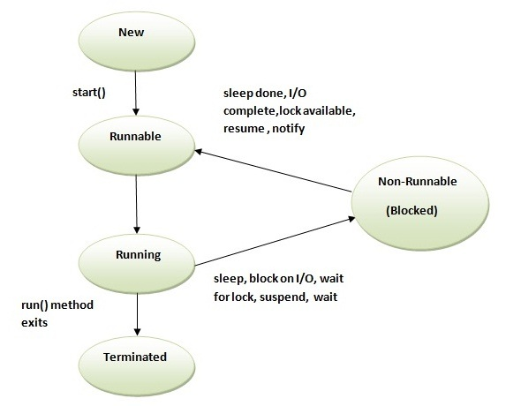

- New - The thread is in new state if you create an instance of Thread class but before the invocation of start() method
- Runnable - The thread is in runnable state after invocation of start () method, but the thread scheduler has not selected it to be the running thread.
- Running - The thread is in running state if the thread scheduler has selected it.
- Non-Runnable (Blocked) - This is the state when the thread is still alive, but is currently not eligible to run.
- Terminated - A thread is in terminated or dead state when its run () method exits.
- From Runnable to Running, we invoke a start() method which intern invoke run() {} method
- From Running to Non-Runnable state, there are 3 ways:
Using sleep(ms) method: After specified period thread automatically comes back to running state
Using suspend() method: If we call resume(), then only suspended thread comes back to running state
Using wait() method : If we call notify() / notifyAll(), then only suspended thread comes back to running state
- From Running state to Terminated state: Control come out of the run() method
- It is the run () method where entire execution of a thread is defined.
- Since JDK1.2 stop (), suspend () and resume () have been deprecated.

Question- Why is Thread.stop() has been deprecated?
This method is deprecated for the simple reason that it's unsafe and may lead the program to some unexpected circumstances. Thread.stop() when called, it causes the thread to release all the acquired monitors and throw a ThreadDeath error, which ultimately causes the thread to die. Since, the thread releases all the acquired monitors immediately, so it may leave few objects (whose monitors were acquired by the thread) in an inconsistent state. Such objects are called damaged objects and obviously they may result into some arbitrary behavior.

Question- Why are Thread.suspend and Thread.resume deprecated?
Thread.suspend is inherently deadlock-prone. If the target thread holds a lock on the monitor protecting a critical system resource when it is suspended, no thread can access this resource until the target thread is resumed. If the thread that would resume the target thread attempts to lock this monitor prior to calling resume, deadlock results. Such deadlocks typically manifest themselves as "frozen" processes.

Different ways to create a Thread
- Two ways for creating a thread
1) Extending from Thread class
2) Implementing Runnable Interface

- Steps to create a Thread by extending Thread class
1) Extend Thread class into your class
2) Override run() method // Optional
3) Create an instance of your class (Will give you thread instance)
4) Start the thread

- Steps to create a Thread by implementing Runnable Interface
1) Implement Runnable interface into your class
2) Override run() method
3) Create an instance of your class (Will give you runnable instance)
4) Create a Thread object by passing Runnable object as parameter
5) Start the thread

Question- Which one the above way is preferred?

Question- Can I call run () method directly?

Example of Runnable- com.src.java.multithreading – DisplayBanner.java, TestBanner.java
Example of Thread Class- com.src.java.multithreading – DisplayThread.java, TestThread.java

Working with a Thread
- Following classes and interface: Thread; ThreadGroup; Runnable; All these resides in the lang package.

- Every thread have their own properties-
Every thread has a name- getName () / setName ()
Every thread has a priority- getPriority () / setPriority(): 1-10
Every thread belongs to a Group- getThreadGroup() : default is main
For example - main thread: main / 5/ main

- By default thread name is assigned by thread API: Thread0, Thread1, and Thread2…
By default thread group name always based on the name of the parent group.
Normal priority of any thread is 5. 1 is minimum and 10 is maximum. If we provide priority out this range, then will get an illegalArgumentException.

- Thread.Sleep () Method-
Sleep method in Thread tells the currently executing thread to sleep for specified amount of time.
Sleep method accepts the time in MilliSeconds. However, these sleep times are not guaranteed to be precise, because they are limited by the facilities provided by the underlying OS.
It can throw interruptedException. So it should be embedded in the try catch block.
Once the thread completes or out of its sleep state, it can move to Running or Runnable state.
Example - com.src.java.multithreading – SleepMessages.java

- threadObject.Join () throws InterruptedException: It is used to impose order on execution of multiple Threads. The join () method waits for a thread to die.
In other words, it causes the currently running threads to stop executing until the thread it joins with completes its task. However, as with sleep, join is dependent on the OS for timing, so you should not assume that join will wait exactly as long as you specify.

Question- You have three threads T1, T2 and T3, How do you ensure that they finish in order T1, T2, T3 ?

Example - com.src.java.multithreading – ThreadJoinExample.java, MyRunnable.java, JoinExample.java

- Threads work in 2 ways-
1) pre-emptive multithreading where all threads get chance to execute
2) co-operative multithreading which is also called as selfish thread where highest get chance to execute first. If we want to make it unselfish, we can use yield () method provided that all threads having same priority. Yield will gives up execution of current thread and will go in running state. So that next thread comes and running.

- isAlive()

- ThreadGroup.setMaxPriority()
ThreadGroup tg1 = new ThreadGroup();
t1, t2, and t3 belongs to tg1
t1.setPriority(9);
tg1.setMaxPriority(8);
t2.setPriority(9);
t3.setPriority(6);
S.O.P(t1.getPriority()); // 9
S.O.P(t2.getPriority()); // 8
S.O.P(t3.getPriority()); // 6
t1.setPriority(10);
S.O.P(t1.getPriority()); // 8

- There are 2 types of Thread-
User thread and Daemon Thread (System thread running in background like Garbage collector which is having low priority).
User Thread- When we create a thread object and call start () method then it is a User Thread
Daemon Thread- When we create a thread object and before calling start () method if we call setDaemon(true) and then call start() method then it is a Daemon thread.
Once we start a thread we can’t change the type of a thread.
Any thread which is a Daemon thread, within which we are creating a child thread, then children will also be a Daemon thread.
IsDaemon () method return the type of thread.
JVM run till all the user threads are alive. Once all users thread ends then JVM has responsibility to kill all Daemon thread and get out of the execution from your program. That’s why we can’t define same task inside a user thread instead of a Daemon thread.
User can’t kill a Daemon thread otherwise it will give an exception.

- What's the difference between the methods sleep () and wait ()?
Sleep ():
It is a static method on Thread class. It makes the current thread into the "Not Runnable" state for specified
amount of time. During this time, the thread keeps the lock (monitors) it has acquired.

Wait ():
It is a method on Object class. It makes the current thread into the "Not Runnable" state. Wait is called on an
object, not a thread. Before calling wait () method, the object should be synchronized, means the object should
be inside synchronized block.
The call to wait () releases the acquired lock.

Question- I have method run () in a Class SimpleSchedular. I want to create a schedular so those run () get called in every 5mins interval.
com.src.java.multithreading – SimpleSchedular.java

Locks / Thread synchronization
- Synchronization is built around an internal entity known as the intrinsic lock or monitor lock. Every object has an intrinsic lock associated with it. By convention, a thread that needs exclusive and consistent access to an object's fields has to acquire the object's intrinsic lock before accessing them, and then release the intrinsic lock when it's done with them. A thread is said to own the intrinsic lock between the time it has acquired the lock and released the lock. As long as a thread owns an intrinsic lock, no other thread can acquire the same lock. The other thread will block when it attempts to acquire the lock.

- When a thread invokes a synchronized method, it automatically acquires the intrinsic lock for that method's object and releases it when the method returns. The lock release occurs even if the return was caused by an uncaught exception.

- You might wonder what happens when a static synchronized method is invoked, since a static method is associated with a class, not an object. In this case, the thread acquires the intrinsic lock for the Class object associated with the class. Thus access to class's static fields is controlled by a lock that's distinct from the lock for any instance of the class.

- The synchronized keyword in Java ensures that only a single thread can execute a block of code at the same time.

- Either synchronized a method OR synchronize a block using Synchronized modifier.
Synchronized public void m() {
}
OR
public void m() {
Synchronized(<object>) {
}
}
Example - com.src.java.multithreading.lock – PrintDemo.java, ThreadDemo.java, SyncrinizedThreadExample.java, SynchronizedThreadDemo.java

- Scenario - Let’s suppose we have an online banking system, where people can log in and access their account information. Whenever someone logs in to their account online, they receive a separate and unique thread so that different bank account holders can access the central system simultaneously.
Let’s say that there’s a husband and wife - Jack and Jill - who share a joint account. They currently have 3,000 in their account. They both log in to their online bank account at the same time, but from different locations.
They both decide to deposit 1000 each into their account through a wire transfer from other bank accounts that they have at the same time. So, the total account balance after these 2 deposits should be 3,000 + (1000 * 2), which equals 5,000.
Now, the processor is running the thread for Jack, who is also depositing 1000 into their account. When Jack’s thread deposits 1000, the account balance is still only $1,000, because the variable accountBalance has not yet been updated in Jill’s thread. Remember that Jill’s thread stopped execution right before the accountBalance variable was updated.
So, Jack’s thread runs until it completes the deposit function, and then updates the value of the accountBalance variable to 4000. After this, control returns to Jill’s thread, where newAccountBalance has the value of 4000. Then, it just assigns this value of 4000 to accountBalance and returns. And that is the end of execution.
What is the result of these 2 deposits of 1000? Well, the accountBalance variable ends up being set to only 4000, when it should have been 5000. This means Jack and Jill lost 1000. This is good for the bank, but a huge problem for Jack and Jill, and any other of the bank's customers.
Example - com.src.java.multithreading.lock – BankAccount.java, DepositMoney.java, WithdrawMoney.java, AccountTesting.java

- Few important points-
  - Synchronized keyword can be used only with methods and code blocks. These methods or blocks can be static or non-static both.
  - When ever a thread enters into java synchronized method or block it acquires a lock and whenever it leaves java synchronized method or block it releases the lock. Lock is released even if thread leaves synchronized method after completion or due to any Error or Exception.
  - Java synchronized keyword is re-entrant in nature it means if a java synchronized method calls another synchronized method which requires same lock then current thread which is holding lock can enter into that method without acquiring lock.
  - Java Thread acquires an object level lock when it enters into an instance synchronized java method and acquires a class level lock when it enters into static synchronized java method.
  - Java Synchronization will throw NullPointerException if object used in java synchronized block is null.
  - One Major disadvantage of Java synchronized keyword is that it doesn't allow concurrent read, which can potentially limit scalability. By using concept of lock stripping and using different locks for reading and writing, you can overcome this limitation of synchronized in Java. You will be glad to know that java.util.concurrent.locks.ReentrantReadWriteLock provides ready made implementation of ReadWriteLock in Java.
  - One more limitation of java synchronized keyword is that it can only be used to control access of shared object within the same JVM. If you have more than one JVM and need to synchronized access to a shared file system or database, the Java synchronized keyword is not at all sufficient. You need to implement a kind of global lock for that.
  - Java synchronized block is better than java synchronized method in Java because by using synchronized block you can only lock critical section of code and avoid locking whole method which can possibly degrade performance.

Volatile variables
The Java volatile keyword is used to mark a Java variable as "being stored in main memory". More precisely that means, that every read of a volatile variable will be read from the computer's main memory, and not from the CPU cache, and that every write to a volatile variable will be written to main memory, and not just to the CPU cache.
In a multithreaded application where the threads operate on non-volatile variables, each thread may copy variables from main memory into a CPU cache while working on them, for performance reasons. If your computer contains more than one CPU, each thread may run on a different CPU. That means that each thread may copy the variables into the CPU cache of different CPUs.
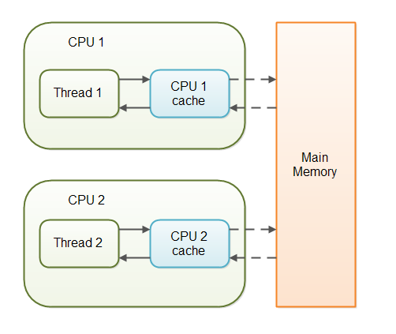
With non-volatile variables there are no guarantees about when the Java Virtual Machine (JVM) reads data from main memory into CPU caches, or writes data from CPU caches to main memory.

Scenario-
public class SharedObject { public int counter = 0;}
Thread 1 could read a shared counter variable with the value 0 into its CPU cache, increment it to 1 and not write the changed value back into main memory. Thread 2 could then read the same counter variable from main memory where the value of the variable is still 0, into its own CPU cache. Thread 2 could then also increment the counter to 1, and also not write it back to main memory. Thread 1 and Thread 2 are now practically out of sync. The real value of the shared counter variable should have been 2, but each of the threads has the value 1 for the variable in their CPU caches, and in main memory the value is still 0. It is a mess! Even if the threads eventually write their value for the shared counter variable back to main memory, the value will be wrong.

By declaring the shared counter variable volatile the JVM guarantees that every read of the variable will always be read from main memory, and that all writes to the variable will always be written back to main memory. If Thread A writes to a volatile variable and Thread B subsequently reads the same volatile variable, then all variables visible to Thread A before writing the volatile variable, will also be visible to Thread B.
public class SharedObject { public volatile int counter = 0;}
Reading and writing of volatile variables causes the variable to be read or written to main memory. Reading from and writing to main memory is more expensive than accessing the CPU cache.

Wait – Notify - NotifyAll
- Dead Lock - Dining Philospher problem
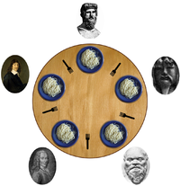
/**The dining philosophers problem is summarized as five silent philosophers
* sitting at a circular table doing one of two things: eating or thinking.
* While eating, they are not thinking, and while thinking, they are not eating.
* A large bowl of Rice is placed in the center, which requires two forks
* to serve and to eat. A fork is placed in between
* each pair of adjacent philosophers, and each philosopher may only use the
* fork to his left and the fork to his right. However, the philosophers do not
* speak to each other. Deadlock would arise if every philosopher held a left
* fork and waited perpetually for a right fork (or vice versa). Originally used
* as a means of illustrating the problem of deadlock, this system reaches
* deadlock when there is a 'cycle of unwarranted requests'. In this case
* philosopher P1 waits for the fork grabbed by philosopher P2 who is waiting
* for the fork of philosopher P3 and so forth, making a circular chain.
*/
Example - com.src.java.multithreading.lock – Fork.java, Philospher.java, Dining.java

- To resolve Producer-consumer issue we can use Wait / Notify / NotifyAll
Example - com.src.java.multithreading.lock – Stock.java, Producer.java, Consumer.java, ProducerConsumerTestClient.java

Inter – Thread Communication
In multithreading, a thread has a local data which is required to be passed to another thread and based upon data another thread get processed it. This approach is called as Inter-thread communication. An inter-thread communication always achieved via pipes. This is the place where we use PipedInputStream / PipedOutputStream class or PipedReader / PipedWriter class.

Scenario - There are two threads: Number Generator thread always generating a random number and passed through pipes which will be used by Average Generator thread to calculate the average.

Example - com.src.java.multithreading.lock – PipeTest.java, NumGen.java, RunningAvg.java

Executors, Schedule Executor & Thread Pool
Thread pools manage a pool of worker threads. The thread pool contains a work queue which holds tasks waiting to get executed.

A thread pool can be described as a collection of Runnable objects (work queue) and a connection of running threads. These threads are constantly running and are checking the work query for new work. If there is new work to be done they execute this Runnable. The Thread class itself provides a method, e.g. execute (Runnable r) to add a new Runnable object to the work queue.

The Executor framework provides example implementation of the java.util.concurrent.Executor interface, e.g. Executors.newFixedThreadPool (int n) which will create n worker threads. The ExecutorService adds life cycle methods to the Executor, which allows to shutdown the Executor and to wait for termination.

ScheduledThreadExecutor provides multiple working threads by using Thread pool. This class extends ThreadPoolExecutor class and uses thread pool to have a pool of threads to execute multiple tasks in parallel.
Example - com.src.java.multithreading.lock – MyRunnable.java, ExecutorServiceExample.java, ScheduleExecutorServiceExample.java

Futures and Callables
The executor framework presented above works with Runnables. Runnable do not return result. In case you expect your threads to return a computed result you can use java.util.concurrent.Callable. The Callable object allows returning values after completion.

The Callable interface is similar to Runnable, in that both are designed for classes whose instances are potentially executed by another thread. A Runnable, however, does not return a result and cannot throw a checked exception.

The Callable object uses generics to define the type of object which is returned.
If you submit a Callable object to an Executor the framework returns an object of type java.util.concurrent.Future. This Future object can be used to check the status of a Callable and to retrieve the result from the Callable.
On the Executor you can use the method submit to submit a Callable and to get a future. To retrieve the result of the future we can use the get () method.
A Future represents the result of an asynchronous computation. Methods are provided to check if the computation is complete, to wait for its completion, and to retrieve the result of the computation. The result can only be retrieved using method get when the computation has completed
Example - com.src.java.multithreading.lock – MyCallable.java, CallableFutures.java

Nonblocking algorithms
Java 5.0 provides supports for additional atomic operations. This allows to develop algorithm which are non-blocking algorithm, e.g. which do not require synchronization, but are based on low-level atomic hardware primitives such as compare-and-swap (CAS). A compare-and-swap operation checks if the variable has a certain value and if it has this value it will perform this operation. This operation takes three parameters, the memory address, the expected current value and the new value. It atomically update the value at the given memory address if the current value is the expected.
Non-blocking algorithm are usually much faster then blocking algorithms as the synchronization of threads appears on a much finer level (hardware).
Example - com.src.java.multithreading.lock – Counter.java, UniqueCounter.java, AtomicTest.java

ReentrantLock
This is the most widely used implementation class of Lock interface. This class implements the Lock interface in similar way as synchronized keyword. Apart from Lock interface implementation, ReentrantLock contains some utility methods to get the thread holding the lock, threads waiting to acquire the lock etc.

Example - com.src.java.multithreading.lock – Resource.java, ConcurrencyLockExample.java, ConcurrencyLockClient.java

Lock vs synchronized
- Lock provides more visibility and options for locking, unlike synchronized where a thread might end up waiting indefinitely for the lock, we can use tryLock () to make sure thread waits for specific time only.
- Synchronization code is much cleaner and easy to maintain whereas with Lock we are forced to have try-finally block to make sure Lock is released even if some exception is thrown between lock() and unlock() method calls.
- Synchronization blocks or methods can cover only one method whereas we can acquire the lock in one method and release it in another method with Lock API.

Java 5 features

For each loop

Iterating over a collection is uglier than it needs to be. Consider the following method, which takes a collection of timer tasks and cancels them:
void cancelAll(Collection<TimerTask> c) {
for (Iterator<TimerTask> i = c.iterator(); i.hasNext(); )
i.next().cancel();
}
The iterator is just clutter. Furthermore, it is an opportunity for error. The iterator variable occurs three times in each loop: that is two chances to get it wrong. The for-each construct gets rid of the clutter and the opportunity for error. Here is how the example looks with the for-each construct:
void cancelAll(Collection<TimerTask> c) {
for (TimerTask t : c)
t.cancel();
}
When you see the colon (:) read it as “in.” The loop above reads as “for each TimerTask t in c.”
Example - com.src.java.java5 – MainClass.java, ForEachLoop.java

Var-args
Last argument can only be used as variable argument.
Example - com.src.java.java5 – VarGridLayout.java, VarArgsExample.java

AutoBoxing
Java 5 (and hence AspectJ 1.5) supports automatic conversion of primitive types (int, float, double etc.) to their object equivalents (Integer, Float, Double,...) in assignments and method and constructor invocations. This conversion is known as autoboxing.
Java 5 also supports automatic unboxing, where wrapper types are automatically converted into their primitive equivalents if needed for assignments or method or constructor invocations.
For example:
int i = 0;
i = new Integer(5); // auto-unboxing

Integer i2 = 5; // autoboxing

Generics
Generics allow you to abstract over types.
Note: Already discussed most of the concept of Generics inside Collection.

Upper Bounded Wildcards
You can use an upper bounded wildcard to relax the restrictions on a variable. For example, say you want to write a method that works on List<Integer>, List<Double>, and List<Number>; you can achieve this by using an upper bounded wildcard.
To declare an upper-bounded wildcard, use the wildcard character ('?'), followed by the extends keyword, followed by its upper bound. Note that, in this context, extends is used in a general sense to mean either "extends" (as in classes) or "implements" (as in interfaces).
To write the method that works on lists of Number and the subtypes of Number, such as Integer, Double, and Float, you would specify List<? extends Number>. The term List<Number> is more restrictive than List<? extends Number> because the former matches a list of type Number only, whereas the latter matches a list of type Number or any of its subclasses.
For example-
The sumOfList method returns the sum of the numbers in a list:
public static double sumOfList(List<? extends Number> list) {
double s = 0.0;
for (Number n : list)
s += n.doubleValue();
return s;
}
The following code, using a list of Integer objects, prints sum = 6.0:
List<Integer> li = Arrays.asList(1, 2, 3);
System.out.println("sum = " + sumOfList(li));
A list of Double values can use the same sumOfList method. The following code prints sum = 7.0:
List<Double> ld = Arrays.asList(1.2, 2.3, 3.5);
System.out.println("sum = " + sumOfList(ld));

Lower Bounded Wildcards
The Upper Bounded Wildcards section shows that an upper bounded wildcard restricts the unknown type to be a specific type or a subtype of that type and is represented using the extends keyword. In a similar way, a lower bounded wildcard restricts the unknown type to be a specific type or a super type of that type.
A lower bounded wildcard is expressed using the wildcard character ('?'), following by the super keyword, followed by its lower bound: <? super A>.

Note: You can specify an upper bound for a wildcard, or you can specify a lower bound, but you cannot specify both.

Say you want to write a method that puts Integer objects into a list. To maximize flexibility, you would like the method to work on List<Integer>, List<Number>, and List<Object> — anything that can hold Integer values.
To write the method that works on lists of Integer and the supertypes of Integer, such as Integer, Number, and Object, you would specify List<? super Integer>. The term List<Integer> is more restrictive than List<? super Integer> because the former matches a list of type Integer only, whereas the latter matches a list of any type that is a supertype of Integer.
The following code adds the numbers 1 through 10 to the end of a list:
public static void addNumbers(List<? super Integer> list) {
for (int i = 1; i <= 10; i++) {
list.add(i);
}
}

Enum
We can use this to define GLOBAL Constants inside our application.
An enum type is a type whose fields consist of a fixed set of constants. Common examples include compass directions (values of NORTH, SOUTH, EAST, and WEST) and the days of the week.
Because they are constants, the names of an enum type's fields are in uppercase letters.
In the Java programming language, you define an enum type by using the enum keyword. For example, you would specify a days-of-the-week enum type as:
public enum Day {
SUNDAY, MONDAY, TUESDAY, WEDNESDAY,
THURSDAY, FRIDAY, SATURDAY
}

You should use enum types any time you need to represent a fixed set of constants. That includes natural enum types such as the planets in our solar system and data sets where you know all possible values at compile time—for example, the choices on a menu, command line flags, and so on.
Example - com.src.java.java5 – Day.java, EnumTest.java, MyConstants.java, EnumMyConstantExample.java

Covariant Return
A covariant return type means changing a method's return type when overriding it in a subclass.

For Example-
// Classes used as return types:

class A {
}

class B extends A {
}

// Classes demonstrating method overriding:

class C {
A getFoo() {
return new B();
}
}

class D extends C {
B getFoo() {
return new B();
}
}
For Example-
interface X {

}

class A implements X{
A a() {
return new A();
}
}

class B extends A {
A a() {
return new B();
}
}

class C extends B {
A a() {
return new C();
}
}

class D implements X {
X a() {
X interf = new D();
return new D();
}
}
public class CovariantReturn {

}

Annotation
- Annotations are generally a way to add meta-data information to an element (an element can be a class, method, field, or anything) and these meta-data are processed by the tools (compilers, javadoc, etc.). Annotations are differentiated from other elements like class, interface etc., by preceeding a '@' symbol before it.
An annotation definition looks like the following,
public @interface TestAnnotation {
////
}
- Metadata are data about data. In the context of computer programs, metadata are data about the code.
- For annotating any element, we need to define 2 basic things:
1) Target Annotation- The argument to @Target Annotation can be one from the possible set of values of any Java Element, which is defined in a well-defined Enum called ElementType. Here are the possible values taken by this Enum,
  - TYPE – Applied only to Type. A Type can be a Java class or interface or an Enum or even an Annotation.
  - FIELD – Applied only to Java Fields (Objects, Instance or Static, declared at class level).
  - METHOD – Applied only to methods.
  - PARAMETER – Applied only to method parameters in a method definition.
  - CONSTRUCTOR – Can be applicable only to a constructor of a class.
  - LOCAL_VARIABLE – Can be applicable only to Local variables. (Variables that are declared within a method or a block of code).
  - ANNOTATION_TYPE – Applied only to Annotation Types.
  - PACKAGE – Applicable only to a Package.
2) Retention Annotation- We has mechanism through which we can say that to what extent the Annotations should be retained. The three possible ways of telling this are,
- Retain the Annotation in the Source Code only
- Retain the Annotation in the Class file also
- Retain the Annotation Definition during the Run-time so that JVM can make use of it
The Annotation that is used to achieve this is @Retention and it takes a possible value of SOURCE, CLASS and RUNTIME defined in RetentionPolicy Enumeration.
For Example-
@Target(ElementType.METHOD)
@Retention(RetentionPolicy.CLASS)
public @interface TestAnnotation
{
// Property Definitions here.
}

- Built-in Annotation in Java
There are some pre-defined annotations available in the Java Programming language. They are:
Override, Deprecated, SuppressWarnings
- For Example-
Suppress Warnings can be used on various Java elements like Class/Interface, Method, Constructor etc. When applied on any of the Java Elements along with a value, it provides a hint to the Compiler to turn-off the warnings.
@SuppressWarnings("unchecked")
public static List toList(Object[] array)
{
return Arrays.asList(array);
}

Java Annotation Types
There are three annotation types:
- Marker: Marker type annotations have no elements, except the annotation name itself.
Example:
public @interface MyAnnotation {
}
Usage:
@MyAnnotation
public void mymethod() {
....
}
- Single-Element: Single-element, or single-value type, annotations provide a single piece of data only. This can be represented with a data=value pair or, simply with the value (a shortcut syntax) only, within parenthesis.
Example:
public @interface MyAnnotation
{
String doSomething();
}
Usage:
@MyAnnotation ("What to do")
public void mymethod() {
....
}
- Full-value or multi-value: Full-value type annotations have multiple data members. Therefore, you must use a full data=value parameter syntax for each member.
Example:
public @interface MyAnnotation {
String doSomething();
int count(); String date();
}
Usage:
@MyAnnotation (doSomething="What to do", count=1,
date="09-09-2005")
public void mymethod() {
....
}

  - Rules to define Java annotation Type
Annotation declaration should start with an 'at' sign like @, following with an interface keyword, following with the annotation name.
Method declarations should not have any parameters.
Method declarations should not have any throws clauses.
Return types of the method should be one of the following: primitives, String, Class, enum,array of these types
- User-defined Annotations-
We need to define annotation interface as well as annotation processor using reflection.
Example - com.src.java.java5 – Author.java, Version.java, AnnotatedClass.java, AnnotationReader.java

Static Import
In order to access static members, it is necessary to qualify references with the class they came from. For example, one must say:
double r = Math.cos(Math.PI * theta);
The static import construct allows unqualified access to static members without inheriting from the type containing the static members. Instead, the program imports the members, either individually:
import static java.lang.Math.PI;
OR
import static java.lang.Math.*;

Once the static members have been imported, they may be used without qualification:
double r = cos(PI * theta);

The static import declaration is analogous to the normal import declaration. Where the normal import declaration imports classes from packages, allowing them to be used without package qualification, the static import declaration imports static members from classes, allowing them to be used without class qualification.

JDBC Connectivity

Types of Driver
There are 4 types of drivers:
- Type I – also called as “JDBC - ODBC” driver.
JAVA API talks to Native API and then it talks to the Database.
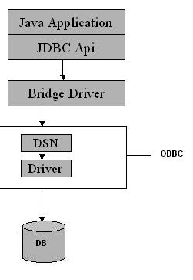
- Type II – also called as “Thick / Native” OR Partial Java driver.
There is a Native API which will talks to the Database.
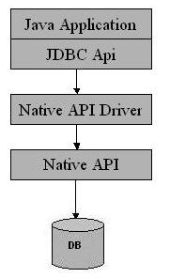
- Type III – also called as “All Java/Net Protocol” driver.
It is the driver which is based on 3-tier architecture. Client talks to the server using Net Protocol
driver and then server talks to the Database using any of the other driver (I / II / IV). It would be use where lots of concurrency to access to a database, lots of traffic to access to a database.
It requires another server application to install and maintain. Traversing the recordset may take longer, since the data comes through the backend server.

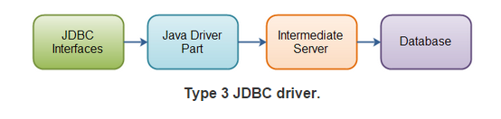

- Type IV – also called as “Thin / Pure” driver.
It is Pure JAVA API which directly talks to the database. Most often we use Type IV driver. Therefore, type IV is faster and most popular driver 4 types of JDBC Driver
With type 4 drivers, the user needs a different driver for each database.
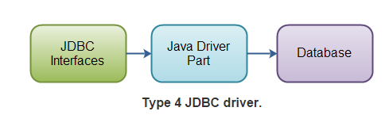

Install & Configure Database
Install any database like mysql, hsqldb, etc
- For HSQLDB, download it from - http://sourceforge.net/projects/hsqldb/files/hsqldb/hsqldb_2_3/

- Inside Eclipse-> Window -> Show View -> Other -> Data Source Explorer

- Right click on “Database Connection” -> Select “HSQLDB” as connection profile -> Select driver using New driver definition -> Specify Jar file “hsqldb.jar” inside hsqldb-2.3.2\hsqldb\lib

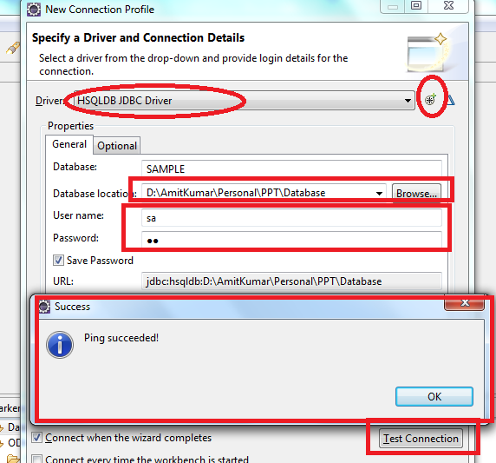

- Provide database location, password & then Test Connection -> Ping succeeded

- Next -> Finish

- Add driver into your classpath

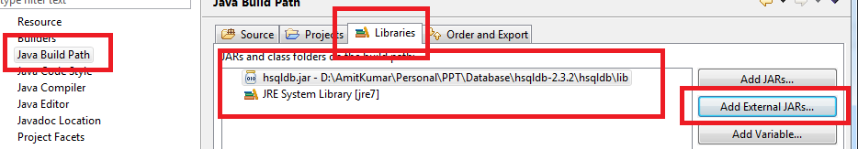

- Install MySQL 5.5 Database (default port: 3306, Username: root & Password: root)

- Install Client App like navicat100_lite_en to connect to database

- Open Navicat -> Create new Database Connection using MySQL
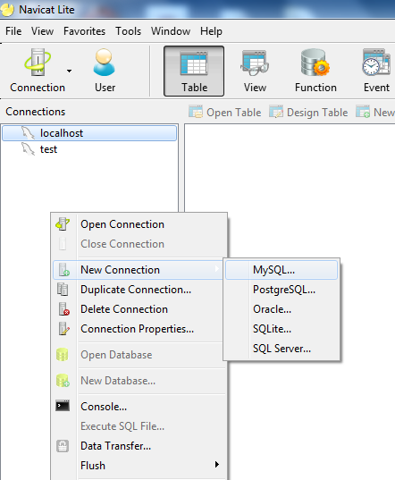
- “GpsConnection” & Test Connection -> finally OK
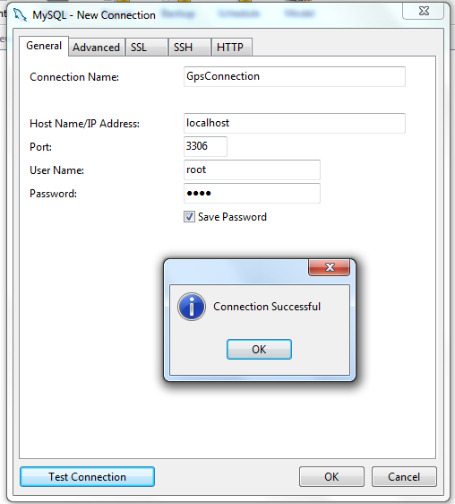
- Create new database “gpsdb” & set mysql-connector-java java to classpath

Steps to Create a Database Connection
Steps to Create a JDBC Connection are:
- Loading the driver using class.forName
Class.forName(driver).newInstance();
- Establishing JDBC Connection either using Driver Manager / Data Source
Connection con = DriverManager.getConnection(url+db, user, pass);
OR
Connection con = new DataSource().getConnection();
- Prepare SQL Statement / Prepared Statement
String SQL = “SELECT * FROM employee”;
Statement st = con.createStatement();
- Execute the query
ResultSet res = st.executeQuery( SQL);
- Process the Result
while (res.next()) {
String employeeName = res.getInt( " employee_name " );
System.out.println( employeeName );
}
- Close the Connection
con.close();

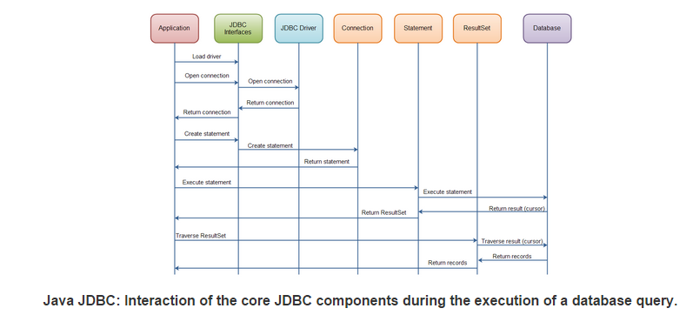

Create few table using SQL Scrapbook
Create table Employee (
EmpID varchar(200),
EmpName varchar(200),
EmpSalary float,
EmpAge int
);

insert into Employee values ('GPS0001','Amit',222.2,34);
insert into Employee values ('GPS0002','Amit1',223.2,35);
insert into Employee values ('GPS0003','Amit2',224.2,36);
commit;

Database URL’s
RDBMS | JDBC driver name | URL format
MySQL | com.mysql.jdbc.Driver | jdbc:mysql://hostname/ databaseName
ORACLE | oracle.jdbc.driver.OracleDriver | jdbc:oracle:thin:@hostname:port Number:databaseName
DB2 | COM.ibm.db2.jdbc.net.DB2Driver | jdbc:db2:hostname:port Number/databaseName
Sybase | com.sybase.jdbc.SybDriver | jdbc:sybase:Tds:hostname: port Number/databaseName

Read data from Database using Statement
Example - com.src.java.jdbc – ReadData.java

Read data from Database using PreparedStatement
Example - com.src.java.jdbc – ReadDataByPS.java

Question: Difference between Statement and PreparedStatement?
A Statement is usually parsed and executed each time it is submitted to the database. A PreparedStatement may be parsed once and executed repeatedly with different parameters.
Most relational databases handle a JDBC / SQL query in four steps:
1. Parse the incoming SQL query
2. Compile the SQL query
3. Plan/optimize the data acquisition path
4. Execute the optimized query / acquire and return data
A Statement will always proceed through the four steps above for each SQL query sent to the database. A PreparedStatement pre-executes steps (1) - (3) in the execution process above. Thus, when creating a PreparedStatement some pre-optimization is performed immediately. The effect is to lessen the load on the database engine at execution time

Read data from Database using DataSource
Example - com.src.java.jdbc – ReadDataByPSusingDataSource.java

Question: What is difference between DataSource and DriverManager of JDBC?
Connection object got from Datasource.getConnection() ,when closed will be returned back to connection pool..but will not be closed permanently whereas Connection object retrieved from DriverManager.getConnection() when closed will be returned permanently.
One difference between both is that Datasource has properties with it, which represents the Source of data it represents.
Other is, DataSource supports the JNDI Service, so we can give any logical name to that datasource eg. MSSQLDataSource to MS SQL server, MySQLDataSource to MySQL.
One more is, DataSource can be separately created and managed and can be accessed from any of the Application through lookup facility of JNDI. DataSource is the standard interface in JDBC, which need to be implemented by database Driver, can be implemented to maintain the pool of connections.

Question: Do we need to close ResultSet before closing connection?
Yes but depend upon scenario. Most Java programmers close a connection with database directly without closing the ResultSet. This is okay with standalone Java programs, where the Java compiler automatically closes the Resultset for you, but when we deploy this code in a servlet, and then we are not guaranteed this behavior. So to be safe, remember to close the ResultSet explicitly before closing the Connection.

ResultSet Type
When you create a ResultSet there are three attributes you can set. These are-
- Type
- Concurrency
- Holdability
You set these already when you create the Statement or PreparedStatement, like this:
Statement statement = connection.createStatement(ResultSet.TYPE_FORWARD_ONLY,
ResultSet.CONCUR_READ_ONLY, ResultSet.CLOSE_CURSORS_OVER_COMMIT);
PreparedStatement statement = connection.prepareStatement(sql,
ResultSet.TYPE_FORWARD_ONLY, ResultSet.CONCUR_READ_ONLY, ResultSet.CLOSE_CURSORS_OVER_COMMIT
);
At the time of writing there are three ResultSet types:
- ResultSet.TYPE_FORWARD_ONLY
- ResultSet.TYPE_SCROLL_INSENSITIVE
- ResultSet.TYPE_SCROLL_SENSITIVE
The default type is TYPE_FORWARD_ONLY
TYPE_FORWARD_ONLY means that the ResultSet can only be navigated forward. That is, you can only move from row 1, to row 2, to row 3 etc. You cannot move backwards in the ResultSet.
TYPE_SCROLL_INSENSITIVE means that the ResultSet can be navigated (scrolled) both forward and backwards. You can also jump to a position relative to the current position, or jump to an absolute position. The ResultSet is insensitive to changes in the underlying data source while the ResultSet is open. That is, if a record in theResultSet is changed in the database by another thread or process, it will not be reflected in already openedResulsSet's of this type.
TYPE_SCROLL_SENSITIVE means that the ResultSet can be navigated (scrolled) both forward and backwards. You can also jump to a position relative to the current position, or jump to an absolute position. The ResultSet is sensitive to changes in the underlying data source while the ResultSet is open. That is, if a record in the ResultSet is changed in the database by another thread or process, it will be reflected in already opened ResulsSet's of this type.

ResultSet Concurrency
A ResultSet can have one of two concurrency levels:
- ResultSet.CONCUR_READ_ONLY
- ResultSet.CONCUR_UPDATABLE
CONCUR_READ_ONLY means that the ResultSet can only be read.
CONCUR_UPDATABLE means that the ResultSet can be both read and updated.

ResultSet Holdability
The ResultSet holdability determines if a ResultSet is closed when the commit() method of the underlyingconnection is called.
There are two types of holdability:
- ResultSet.CLOSE_CURSORS_OVER_COMMIT
- ResultSet.HOLD_CURSORS_OVER_COMMIT
The CLOSE_CURSORS_OVER_COMMIT holdability means that all ResultSet instances are closed when connection.commit() method is called on the connection that created the ResultSet.
The HOLD_CURSORS_OVER_COMMIT holdability means that the ResultSet is kept open when the connection.commit() method is called on the connection that created the ResultSet.
The HOLD_CURSORS_OVER_COMMIT holdability might be useful if you use the ResultSet to update values in the database. Thus, you can open a ResultSet, update rows in it, call connection.commit() and still keep the sameResultSet open for future transactions on the same rows.
Insert data into Database
Example - com.src.java.jdbc – InsertData.java

Update data into Database
Example - com.src.java.jdbc – UpdateData.java

Delete data from Database
Example - com.src.java.jdbc – DeleteData.java

Batch Updates
A batch update is a batch of updates grouped together, and sent to the database in one "batch", rather than sending the updates one by one.
Sending a batch of updates to the database in one goes, is faster than sending them one by one, waiting for each one to finish. There is less network traffic involved in sending one batch of updates (only 1 round trip), and the database might be able to execute some of the updates in parallel. The speed up compared to executing the updates one by one, can be quite big.
You can batch SQL inserts, updates and deletes. It does not make sense to batch select statements.
Example of Statement Batch Updates
Statement statement = null;
try{
statement = connection.createStatement();
statement.addBatch("update people set firstname='John' where id=123");
statement.addBatch("update people set firstname='Eric' where id=456");
statement.addBatch("update people set firstname='May' where id=789");
int[] recordsAffected = statement.executeBatch();
} finally {
if(statement != null) statement.close();
}
Example of PreparedStatement Batch Updates
String sql = "update people set firstname=? , lastname=? where id=?";
PreparedStatement preparedStatement = null;
try{
preparedStatement = connection.prepareStatement(sql);
preparedStatement.setString(1, "Gary");
preparedStatement.setString(2, "Larson");
preparedStatement.setLong (3, 123);
preparedStatement.addBatch();
preparedStatement.setString(1, "Stan");
preparedStatement.setString(2, "Lee");
preparedStatement.setLong (3, 456);
preparedStatement.addBatch();
int[] affectedRecords = preparedStatement.executeBatch();
}finally {
if(preparedStatement != null) {
preparedStatement.close();
}
}

Rowset
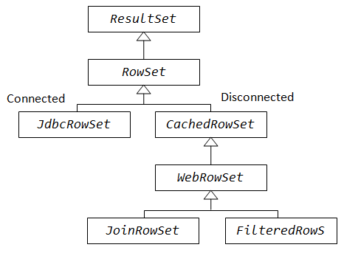
RowSet interface is basically an extension of JDBC ResultSet and is a part of thejavax.sql package. RowSet object holds tabular data in a way that makes it more flexible and easier to use than a result set. A RowSet object is considered either connected or disconnected.
Connected RowSet are those which establish a connection with the database and retain it until the application terminates.
Disconnected RowSet on the other hand establishes a connection, executes a query such as retrieving data from the database and closes the connection.

According to the implementation there are five different categories of RowSet – JdbcRowSet, CachedRowSet, WebRowSet, FilteredRowSet, and JoinRowSet.
Out of these five only JdbcRowSet is connected RowSet, rest of them are disconnected row sets.

JdbcRowSet
It basically acts as a wrapper around the ResultSet object with some additional functionality. The primary advantage of using JdbcRowSet is that it enables theResultSet object to be used as a JavaBeans component.
Example - com.src.java.jdbc – JdbcRowSetDemo.java

CachedRowSet
It is a disconnected RowSet that acts as a container for database records and caches them in memory. In a sense we may think of it as a subset of actual records maintained in memory. This reminds us somewhat of the concept of 'VIEW' we create from the actual table through SQL. Being disconnected, CachedRowSet is more lightweight. On the downside, connection has to be established every time to reflect any changes, performance may be slower than JdbcRowSet but on the upside it is lightweight and we can get a better efficiency when working with large amount of data.

WebRowSet
It extends CachedRowSet capabilities but is very special in the sense that in addition to providing all the features of CachedRowSet, it can read and write XML document. This is particularly seen in an enterprise application scenario or in web service communication. Records fetched from the database can be shipped across tiers over internet protocol in an enterprise application without having to maintain an active connection.
Example - com.src.java.jdbc – WebRowSetDemo.java

FilteredRowSet
It is an extension of WebRowSet. So it has all the capabilities of WebRowSet as well as CachedRowSet. With this RowSet we can apply filtering criteria to fetch selected rows from the data source so that we can work with the relevant data. This RowSet object paves the way for a disconnected yet live filtering mechanism without firing a query into the database every time. We can limit what we want to visualize from the record list without the involvement of a database connection. It is something like using the WHERE clause without writing an SQL.

JoinRowSet
It also extends WebRowSet. In addition to the capabilities of WebRowSet and CachedRowSet, we can perform a SQL JOIN operation without connecting to a data source. ThisRowSet enables us to create SQL JOIN between RowSet objects. Related records from different RowSets can be combined to form thisRowSet object.
Question: What is difference between ResultSet and RowSet?
- A ResultSet maintains a connection to a database and because of that it can’t be serialized and also we can’t pass the Resultset object from one class to other class across the network.
- RowSet is a disconnected, serializable version of a JDBC ResultSet and also the RowSet extends the ResultSet interface so it has all the methods of ResultSet. The RowSet can be serialized because it doesn’t have a connection to any database and also it can be sent from one class to another across the network.

Question: What is difference between Connected and Disconnected RowSet?
- Disconnected database connected to the database only when they want to read or write, all the times they are disconnected from the database, on the other hand, Connected database keep JDBC connection alive all time.
- Only JdbcRowSet from JDBC 4.1 API is connected, rest like CachedRowSet, WebRowSet are disconnected RowSet implementation.
- Disconnected RowSet are Serializable and that's why suitable for sending over the network

CallableStatement
The interface used to execute SQL stored procedures. The JDBC API provides a stored procedure SQL escape syntax that allows stored procedures to be called in a standard way for all RDBMSs. This escape syntax has one form that includes a result parameter and one that does not.

To call stored procedures, you invoke methods in the CallableStatement class. The basic steps are:
- Invoke the Connection.prepareCall method to create a CallableStatement object.
- Invoke the CallableStatement.setXXX methods to pass values to the input (IN) parameters.
- Invoke the CallableStatement.registerOutParameter method to indicate which parameters are output-only (OUT) parameters, or input and output (INOUT) parameters.
- Invoke one of the following methods to call the stored procedure:
CallableStatement.executeUpdate
Invoke this method if the stored procedure does not return result sets.
CallableStatement.executeQuery
Invoke this method if the stored procedure returns one result set.
CallableStatement.execute
Invoke this method if the stored procedure returns multiple result sets.
- If the stored procedure returns result sets, retrieve the result sets.
- Invoke the CallableStatement.getXXX methods to retrieve values from the OUT parameters or INOUT parameters.
- Invoke the CallableStatement.close method to close the CallableStatement object when you have finished using that object.
Eaxmple- Using CallableStatement methods for a stored procedure call with parameter markers
int ifcaret;
int ifcareas;
int xsbytes;
String errbuff;
Connection con;
CallableStatement cstmt;
ResultSet rs;
...
cstmt = con.prepareCall("CALL DSN8.DSN8ED2(?,?,?,?,?)"); 1
// Create a CallableStatement object
cstmt.setString (1, "DISPLAY THREAD(*)"); 2
// Set input parameter (DB2 command)
cstmt.registerOutParameter (2, Types.INTEGER); 3
// Register output parameters
cstmt.registerOutParameter (3, Types.INTEGER);
cstmt.registerOutParameter (4, Types.INTEGER);
cstmt.registerOutParameter (5, Types.VARCHAR);
cstmt.executeUpdate(); // Call the stored procedure 4
ifcaret = cstmt.getInt(2); // Get the output parameter values 6
ifcareas = cstmt.getInt(3);
xsbytes = cstmt.getInt(4);
errbuff = cstmt.getString(5);
cstmt.close();

Example- Retrieving known result sets from a stored procedure
CallableStatement cstmt;
ResultSet rs;
int i;
String s;
...
cstmt.execute(); // Call the stored procedure 1
rs = cstmt.getResultSet(); // Get the first result set 2
while (rs.next()) { // Position the cursor 3
i = rs.getInt(1); // Retrieve current result set value
System.out.println("Value from first result set = " + i);
// Print the value
}
cstmt.getMoreResults(); // Point to the second result set 4a
// and close the first result set
rs = cstmt.getResultSet(); // Get the second result set 4b
while (rs.next()) { // Position the cursor 4c
s = rs.getString(1); // Retrieve current result set value
System.out.println("Value from second result set = " + s);
// Print the value
}
rs.close(); // Close the result set
cstmt.close(); // Close the statement

Connection Pooling using JNDI Services

Inside Tomcat using Servlet.xml
For Example-
<Context path="/pE" docBase="c:/temp/pE" debug="0" reloadable="true" >
<Resource name="jdbc/myDataSource" auth="Container" type="javax.sql.DataSource" />
<ResourceParams name="jdbc/myDataSource">
<parameter>
<name>factory</name>
<value>org.apache.commons.dbcp.BasicDataSourceFactory</value>
</parameter>
<parameter>
<name>dataSourceName</name>
<value>myDataSource</value>
</parameter>
<parameter>
<name>maxActive</name>
<value>25</value>
</parameter>
<parameter>
<name>maxIdle</name>
<value>10</value>
</parameter>
<parameter>
<name>maxWait</name>
<value>10000</value>
</parameter>
<parameter>
<name>url</name>
<value>jdbc:Microsoft:sqlserver://localhost:1433;DatabaseName=pE</value>
</parameter>
<parameter>
<name>username</name>
<value>sa</value>
</parameter>
<parameter>
<name>password</name>
<value>sql</value>
</parameter>
<parameter>
<name>driverClassName</name>
<value>com.microsoft.jdbc.sqlserver.SQLServerDriver</value>
</parameter>
</ResourceParams>
</Context>

Make an entry inside web.xml:
<resource-ref>
<res-ref-name>jdbc/myDataSource</res-ref-name>
<res-type>javax.sql.DataSource</res-type>
<res-auth>Container</res-auth>
</resource-ref>

How we get Connection using JNDI inside Servlet?
import java.io.*;
import java.sql.*;
import javax.naming.*;
import javax.servlet.*;
import javax.servlet.http.*;
import javax.sql.*;

public class validateLogin extends HttpServlet
{
private Connection conn = null;
private ResultSet rs = null;
private PreparedStatement psmt = null;

private String login,password,sql,UserName;;
private boolean userExist=false;
private DataSource ds=null;

public void init(ServletConfig config) throws ServletException
{
try
{
Context initCtx = new InitialContext();
ds = (DataSource) initCtx.lookup("java:comp/env/jdbc/myDataSource");
}
catch (Exception e)
{
throw new ServletException(e.getMessage());
}
}

private Connection getConnection() throws SQLException
{
return ds.getConnection();
}

public void doPost(HttpServletRequest request, HttpServletResponse response) throws ServletException, IOException
{
login = request.getParameter("txtLogin");
password = request.getParameter("txtPassword");

try
{
conn = getConnection();

sql = "select * from jobSeekerDetails where UserName=? and Password=?";
psmt = conn.prepareStatement(sql);
psmt.setString(1,login);
psmt.setString(2,password);

rs = psmt.executeQuery();

if(rs.next())
{
userExist = true;

HttpSession session = request.getSession(true);
session.setAttribute("userLogin",login);
response.sendRedirect("../");
return;
}
else
{
response.sendRedirect("../errorPage.jsp");
}
}
catch(Exception e)
{
System.out.println(e.getMessage() + " validateLogin.jsp Line No : " + 51);
}
finally
{
try
{
rs.close();
conn.close();
}
catch(Exception e){}
}
}
}

Connection Pooling using Context.xml
Tomcat JDBC connection pool can be configured with META-INF/context.xml.
<Context>
<Resource name="jdbc/EmployeeDB"
auth="Container"
type="javax.sql.DataSource"
username="dbusername"
password="dbpassword"
driverClassName="org.hsql.jdbcDriver"
url="jdbc:HypersonicSQL:database"
maxActive="8"
maxIdle="4"/>
</Context>

To use the DataSource in your Java code:
Context initCtx = new InitialContext();
DataSource ds = (DataSource) initCtx.lookup("java:comp/env/jdbc/EmployeeDB");
Connection conn = ds.getConnection();
// ... use this connection to access the database ...
conn.close();

In contrast to Tomcat documentation, there's no need to declare resource-ref in web.xml.

Java 6 features

WebService
Easy way of creating Web Services. Exposing web services with a simple annotation.
Step1 – Create a webservice endpoint interface
Example - com.src.java.java6 – HelloWorld.java
Step2 – Create a webservice endpoint implementation
Example - com.src.java.java6 – HelloWorldImpl.java
Step3 – Create an endpoint publisher
Example - com.src.java.java6 – HelloWorldPublisher.java
Ster4 – Create Webservice client
Example - com.src.java.java6 – HelloWorldClient.java

Rhino
It is Java script engine to ability to run JS from Java. Rhino is written in Java.
Embedded JavaScript can be used for a variety of purposes. Since it is more flexible and easier to configure than hard-coded Java, it can often be used to code business rules that may change often. Scripting expressions are evaluated using the eval() method. Any variables used in the scripting environment can be assigned from within your Java code using the put() method.
ScriptEngineManager manager
= new ScriptEngineManager();
ScriptEngine engine
= manager.getEngineByName("js");
engine.put("age", 21);
engine.eval(
"if (age >= 18){ " +
" print('Old enough to vote!'); " +
"} else {" +
" print ('Back to school!');" +
"}");

> Old enough to vote!

The eval() method also accepts a Reader object, which makes it easy to store scripts in files or other external sources, as in the following example:
ScriptEngineManager manager
= new ScriptEngineManager();
ScriptEngine engine
= manager.getEngineByName("js");
engine.put("age", 21);
engine.eval(new FileReader("c:/voting.js"));

You can also access Java classes and resources from within scripts. The Rhino JavaScript engine supports the importPackage()function, which allows you to import Java packages. Once imported, you can instantiate Java objects within the script just as you would in Java:
engine.eval("importPackage(java.util); " +
"today = new Date(); " +
"print('Today is ' + today);");

Calling methods on Java classes is also easy to do, both on object instances passed to the script engine, and on static class members.
engine.put("name","John Doe");
engine.eval(
"name2 = name.toUpperCase();" +
"print('Converted name = ' + name2);");
> Converted name = JOHN DOE

Why we need it?
One of the more ambitious goals of the JSR 223 specification is to provide for integration of non-Java scripting pages (such as PHP) into a Java web application. This is designed to allow both non-Java scripting pages to be integrated as part of a Java web application, but also for Java classes to be invoked from the scripting pages.

Using scripting languages from Java can be useful in many situations, such as providing extensions to your Java application so that users can write their own scripts to extend or customize the core functionalities. Scripting languages are both simpler to understand and easier to write, so they can be ideal to give (technical) end users the possibility to tailor your product to their needs.

Example - com.src.java.java6 – JavaScriptRunner.java

Derby DB
Java 6 comes with preinstalled relational database, Oracle release of Apache Derby project.
Java DB is installed automatically as a part of JDK.
For a Java DB installation, set the DERBY_HOME environment variable.

Deque
A double-ended queue (dequeue or deque) is an abstract data type that generalizes a queue, for which elements can be added to or removed from either the front or rear. Deque differs from the queue abstract data type or First-In-First-Out List (FIFO), where elements can only be added to one end and removed from the other.
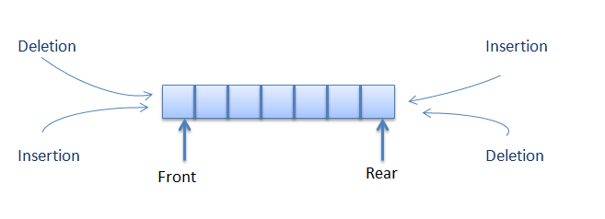
Example - com.src.java.java6 – ArrayDequeExample.java, DoubleEndedQueueImpl.java

JavaTM API for XML Processing (JAXP)
The Java API for XML Processing (JAXP) enables applications to parse, transform, validate and query XML documents using an API that is independent of a particular XML processor implementation. JAXP provides a pluggability layer to enable vendors to provide their own implementations without introducing dependencies in application code. Using this software, application and tool developers can build fully-functional XML-enabled Java applications for e-commerce, application integration, and web publishing.
The Java Platform, Standard Edition version 6.0 includes JAXP 1.4. JAXP 1.4 is a maintenance release of JAXP 1.3 with support for the Streaming API for XML (StAX).
Example - com.src.java.resource - Access.xml
com.src.java.java6 – Access.java, ParseXML.java

JDBC 4.0 Enhancements
Java SE 6 includes several enhancements to the Java Database Connectivity (JDBC) API. These enhancements will be released as JDBC version 4.0. The main objectives of the new JDBC features are to provide a simpler design and better developer experience.
The major features added in JDBC 4.0 include:
    - Auto-loading of JDBC driver class
In JDBC 4.0, we no longer need to explicitly load JDBC drivers using Class.forName(). When the method getConnection is called, the DriverManager will attempt to locate a suitable driver from among the JDBC drivers that were loaded at initialization and those loaded explicitly using the same class loader as the current application.
Connection conn = DriverManager.getConnection(Urldatabase,Username,Password);

    - Support of RowId SQL type. In JDBC 4.0, RowID interface is added to support the ROWID data type which is supported by databases such as Oracle and DB2.
Example - com.src.java.java6 – RowIdExample.java

    - Exception Handling enhancements
It raised a chained exception using enhanced for-loop.
Example - com.src.java.java6 – JdbcExceptionHandling.java

    - JDBC 4.0 SQL XML Support
SQLXML is a mapping in the Java programming language for the XML data type in SQL. XML is a built-in type that stores an XML value as a column value in a row of the target table. By default, drivers implement an SQLXML object as a logical pointer to the XML data rather than the data itself. An SQLXMLobject is valid for the duration of the transaction in which it was created.
SQLXML sqlxml = rs.getSQLXML(column);
InputStream binaryStream = sqlxml.getBinaryStream();
DocumentBuilder parser = DocumentBuilderFactory.newInstance().newDocumentBuilder();
Document doc = parser.parse(binaryStream);

    - Enhance support for Large Objects (BLOBs & CLOBs)

Java 7 features

Strings in switch
Before JDK 7, only integral types can be used as selector for switch-case statement. In JDK 7, you can use a String object as the selector.
Example - com.src.java.java7 – StringConstant.java

Binary Literals with prefix "0b"
In JDK 7, you can express literal values in binary with prefix '0b' (or '0B') for integral types (byte, short, int and long), similar to C/C++ language. Before JDK 7, you can only use octal values (with prefix '0') or hexadecimal values (with prefix '0x' or '0X').
You are also permitted to use underscore (_) to break the digits to improve the readability but you must start and end with a digit.
Example - com.src.java.java7 – BinaryLiteralExample.java

Catching Multiple Exception Types
In JDK 7, a single catch block can handle more than one exception types. The new Use separate catch blocks quick assist allows you to replace a multi-catch clause with individual catch blocks, one for each exception in the multi-catch clause.
try{
….
} catch (FileNotFoundException | IOException | Exception e) {
}

The try-with-resources Statement
Before JDK 7, we need to use a finally block, to ensure that a resource is closed regardless of whether the try statement completes normally or abruptly. The code is messy!
JDK 7 introduces a try-with-resources statement, which ensures that each of the resources in try(resources) is closed at the end of the statement. This results in cleaner codes.

Example - com.src.java.java7 – FileCopyPreJDK7.java, FileCopyJDK7.java

Type Inference for Generic Instance Creation
JDK 7 supports limited type inference for generic instance creation

Example - com.src.java.java7 – JDK7GenericExample.java

Rethrowing Exceptions with Improved Type Checking
- With Java 6
void oldWayRethrow(boolean notFound) throws IOException {
try {
if (notFound) {
throw new FileNotFoundException();
} else {
throw new MalformedURLException();
}
} catch (IOException e) {
throw e;
}
}
- With Java 7
void java7Rethrow(boolean notFound) throws FileNotFoundException,
MalformedURLException {
try {
if (notFound) {
throw new FileNotFoundException();
} else {
throw new MalformedURLException();
}
} catch (IOException e) {
throw e; // 1.6 compiler error:
// "unhandled exception type IOException"
}
}

JUNIT & TDD

Unit tests and unit testing
A unit test is a piece of code written by a developer that executes a specific functionality in the code to be tested. The percentage of code which is tested by unit tests is typically called test coverage.

Unit tests ensure that code works as intended. They are also very helpful to ensure that the code still works as intended in case you need to modify code for fixing a bug or extending functionality. Having high test coverage of your code allows you to continue developing features without having to perform lots of manual tests.

There are several testing frameworks available for Java. The most popular ones are JUnit and TestNG.

The JUnit framework
JUnit in version 4.x is a test framework which uses annotations to identify methods that specify a test. Typically a JUnit test is a method contained in a class which is only used for testing. This is called a Test class.
To write a test with the JUnit 4.x framework you annotate a method with the @org.junit.Test annotation. In this method you use a method provided by the JUnit framework to check the expected result of the code execution versus the actual result.

JUnit naming conventions
There are several potential naming conventions for JUnit tests. In widespread use is to use the name of the class under test and to add the "Test" suffix to the test class.
For the test method names it is frequently recommend to use the word "should" in the test method name, as for example "ordersShouldBeCreated" or "menuShouldGetActive" as this gives a good hint what should happen if the test method is executed.
As a general rule, a test name should explain what the test does so that it can be avoided to read the actual implementation.

JUnit test suites
If you have several test classes, you can combine them into a test suite. Running a test suite will execute all test classes in that suite in the specified order.

The following example code shows a test suite which defines that two test classes (MYClassTest and MySecondClassTest) should be executed. If you want to add another test class you can add it to @Suite.SuiteClasses statement.

@RunWith(Suite.class)
@SuiteClasses({ MyClassTest.class, MySecondClassTest.class })
public class AllTests {
}

TDD Aproach
Traditional approach
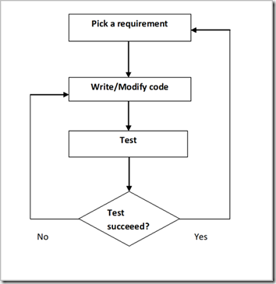

Test driven development
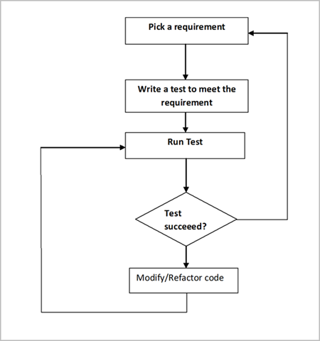

Run your test from the command line
You can also run your JUnit tests outside Eclipse via standard Java code. Build frameworks like Apache Ant or Apache Maven are typically used to execute tests automatically on a regular basis.
The org.junit.runner.JUnitCore class provides the runClasses () method which allows you to run one or several tests classes. As a return parameter you receive an object of the type org.junit.runner.Result. This object can be used to retrieve information about the tests.
The following class demonstrates how to run the MyClassTest. This class will execute your test class and write potential failures to the console.

public static void main(String[] args) {
Result result = JUnitCore.runClasses(MyClassTest.class);
for (Failure failure : result.getFailures()) {
System.out.println(failure.toString());
}
}

Available JUnit annotations
JUnit 4.x uses annotations to mark methods and to configure the test run. The following table gives an overview of the most important available annotations.
Annotation | Description
@Test  public void method() | The @Test annotation identifies a method as a test method.
@Test (expected = Exception.class) | Fails if the method does not throw the named exception.
@Test(timeout=100) | Fails if the method takes longer than 100 milliseconds.
@Before  public void method() | This method is executed before each test. It is used to prepare the test environment (e.g., read input data, initialize the class).
@After  public void method() | This method is executed after each test. It is used to cleanup the test environment (e.g., delete temporary data, restore defaults). It can also save memory by cleaning up expensive memory structures.
@BeforeClass  public static void method() | This method is executed once, before the start of all tests. It is used to perform time intensive activities, for example, to connect to a database. Methods marked with this annotation need to be defined as static to work with JUnit.
@AfterClass  public static void method() | This method is executed once, after all tests have been finished. It is used to perform clean-up activities, for example, to disconnect from a database. Methods annotated with this annotation need to be defined asstatic to work with JUnit.
@Ignore | Ignores the test method. This is useful when the underlying code has been changed and the test case has not yet been adapted. Or if the execution time of this test is too long to be included.

Assert statements
JUnit provides static methods in the Assert class to test for certain conditions. These assertion methods typically start with assertand allow you to specify the error message, the expected and the actual result. An assertion method compares the actual value returned by a test to the expected value, and throws an AssertionException if the comparison test fails.
The following table gives an overview of these methods. Parameters in [] brackets are optional.
Statement | Description
fail(String) | Let the method fail. Might be used to check that a certain part of the code is not reached or to have a failing test before the test code is implemented. The String parameter is optional.
assertTrue([message], boolean condition) | Checks that the boolean condition is true.
assertFalse([message], boolean condition) | Checks that the boolean condition is false.
assertEquals([String message], expected, actual) | Tests that two values are the same. Note: for arrays the reference is checked not the content of the arrays.
assertEquals([String message], expected, actual, tolerance) | Test that float or double values match. The tolerance is the number of decimals which must be the same.
assertNull([message], object) | Checks that the object is null.
assertNotNull([message], object) | Checks that the object is not null.
assertSame([String], expected, actual) | Checks that both variables refer to the same object.
assertNotSame([String], expected, actual) | Checks that both variables refer to different objects.

Examples - com.src.java.testables – Rectangle.java, RandomEmailGenerator.java, MathUtils.java, DomainUtils.java

com.src.java.testables.junit – RectangleTest.java, RandomEmailGeneratorTest.java, MathUtilsTest.java,
DomainUtilsTest.java

com.src.java.testsuite – RunAllTestCases.java

